**Technical Documentation – PENC MiddleWare – Tomcat Service Control**

1. Workflow – Stops, Starts, Restarts Tomcat services that have been configured as a Linux SERVICE (i.e. control is carried out with the ‘sudo /usr/bin/systemctl’ command). Currently this is limited to the RMS and the penc-record-app Tomcat environments. Liferay and MSC Tomcat environments utilize scripts run under the pencmw user to stop and start their services. Once they have been updated to ‘sudo /usr/bin/systemctl’ they can be added.

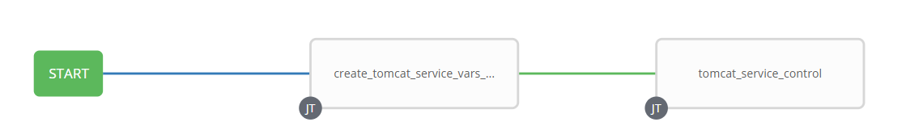

1. Survey – User Supplied Variables

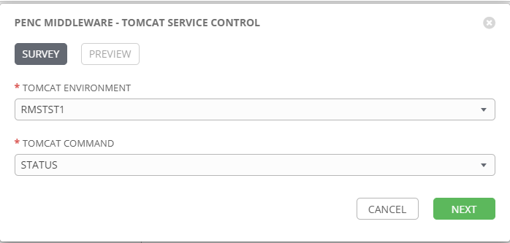

| **Survey Extra Variables** | **Prompt** | **Type** | **Description and Usage** |
| --- | --- | --- | --- |
| tomcat_env | Tomcat Environment | Multiple Choice Single Pick | This is a drop down list of the current Tomcat Environments using /usr/bin/systemctl. It can be modified as more Tomcat Environments are added.  penc-record-app-DEVL  penc-record-app-DEV3  penc-record-app-RDEV  penc-record-app-TST1  penc-record-app-TST2  penc-record-app-TST3  penc-record-app-MUAT  penc-record-app-IPASP  RMSDEVL  RMSDEV3  RMSRDEV  RMSTST1  RMSTST2  RMSTST3  RMSTRNG  RMSMUAT  RMSIPASP |
| tomcat_command | Tomcat Command | Multiple Choice Single Pick | The available commands for /usr/bin/systemctl.  Drop Down List:  RESTART  START  STATUS  STOP |

1. Jobs Used by the workflow - http://owl.penc.local:18080/svn/deploy_automation/trunk/Ansible_PlayBooks/Utilities

| **Job Template** | **Ansible Playbook** | **Credentials / host** | **Project** | **Description and Usage** |
| --- | --- | --- | --- | --- |
| create_tomcat_service_vars_ansible | create_tomcat_service_vars_ansible.yml | None – runs on localhost as awx linux user | Utilities | Creates Variables/Artifacts for use within the workflows, based on the User supplied survey results.  Artifacts Defined with examples  catalina_home: /pencmw/rms/tomcat  catalina_port: 7003  catalina_restart_command: sudo /usr/bin/systemctl restart  catalina_service_name: tomcat.rms  catalina_start_command: sudo /usr/bin/systemctl start  catalina_status_command: sudo /usr/bin/systemctl status  catalina_stop_command: sudo /usr/bin/systemctl stop  date_time: '20201215_0922'  tomcat_host: thoosa1bcp |
| tomcat_service_control | tomcat_service_control.yml | pencmw for {{tomcat_host}} | Utilities | On {{tomcat_host}}:  With {{tomcat_command}} == ‘STATUS’   1. Executes ‘sudo su /usr/bin/systemctl {{tomcat_service}} status’ 2. Emails the output to the Ansible Tower user who initiated the job and to {{mail_list}} not equal to ‘’.   With {{tomcat_command}} == ‘STOP’   1. retrieves the process id for the tomcat service to be stopped into {{tomcat_pid}} variable. 2. executes ‘sudo su /usr/bin/systemctl {{tomcat_service}} stop 3. waits for the /proc/{{tomcat_pid.stdout}}/status to longer exist (i.e. tomcat process no longer exists)   With {{tomcat_command}} == ‘RESTART’   1. executes ‘sudo su /usr/bin/systemctl {{tomcat_service}} restart   With {{tomcat_command}} == ‘START’   1. Checks to see if {{catalina_home}}/logs/catalina.out exists 2. If it does archive it with a date stamp and remove the original catalina.out 3. Execute ‘sudo su /usr/bin/systemctl {{tomcat_service}} start 4. Wait for the Catalina server start message to appear in the catalina.out log 5. Double check that tomcat is listening on the {{catalina_port}}. |

1. Workflow Extra Vars – Defined at the Workflow Level

|  |  |  |
| --- | --- | --- |
| **Extra Variable** | **Example Values** | **Description and Usage** |
| mail_list | ---  mail_list:  - Mike.Charchuk@dxcas.com | If this variable is defined to anything other than ‘’, when the {{tomcat_command}} == STATUS, will email the ‘sudo su /usr/bin/systemctl STATUS’ stdout to email addresses defined in {{mail_list}}.  Note: the following are valid mail_list entries:  mail_list: ‘’  mail_list:   * [Mike.Charchuk@pensionsbc.ca](mailto:Mike.Charchuk@pensionsbc.ca) * [Mike.Charchuk@dxcas.com](mailto:Mike.Charchuk@dxcas.com)   mail_list:   * [Mike.Charchuk@pensionsbc.ca](mailto:Mike.Charchuk@pensionsbc.ca) |